3-1 Project One

DAT-475

Ashley Littles

Southern New Hampshire University

**Problem Statement**

In Tijuana, Mexico a manufacturing company has been building electronic boards that end up going through a welding process. The welding process consists of placing Thru-Holes components on the electric boards and then the assembly which is the combination of the Thru-Holes and electronic boards is welded together in the wave soldering machine. Then a quality inspection worker checks for any welding defects before officially approving the assembly and sending it over to another production line.

The company has recently been experiencing an increase in demand for the products they produce while simultaneously noticing that within the welding process of the electronic boards and the components named Thru-Holes has also had an increase in defects. The known defects are missing components, damaged components, lifted components, solder bridge defect, insufficient solder, and excessive solder. These defects have ultimately led to an insufferable increase in the number of assembly and electronic test issues after these electronic boards have gone through the final process of the assembly.

The manufacturing companies desired outcomes for this issue are reducing the number of defects produced during the manufacturing process by 20% and increase the capacity of their three double production lines where they produce and process the electronic boards by 20%. The manufacturing company would like to achieve these outcomes without any increase in the percentage of defects. It is essential for the manufacturing company to resolve this issue because they must comply with the standard requirements created by IPC-A-610E. The standard IPC-A-610E is a collection of visual quality acceptability requirements for electronic assemblies in general. If the manufacturing company is successful with their resolution, they will be properly complying with production standards and more efficient with the three double production lines. If they are unsuccessful with their resolution, then they will be risking more electronic board defects ultimately causing their company to be shut down.

**Most Significant Causes Pareto Charts**

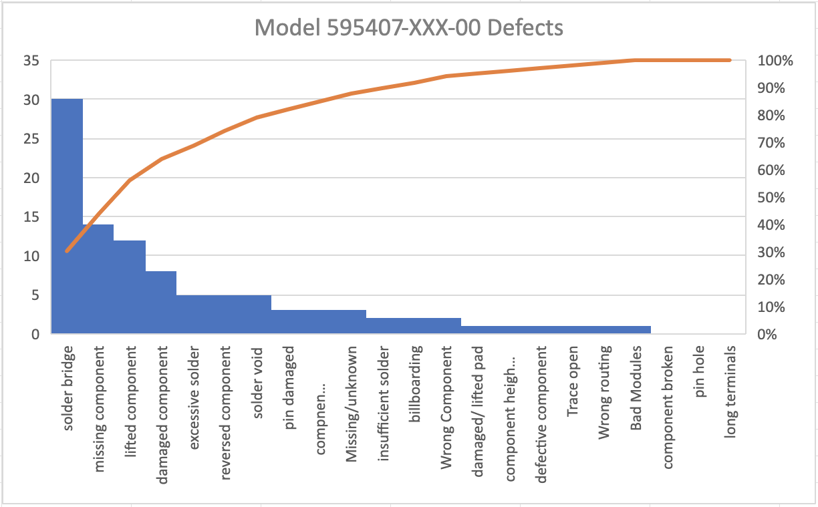

This first pareto chart displays the data from model 595407-XXX-00. Looking at the chart we can see that about 85% of the defects with this model are due to the solder bridge. The next most occurring defect is the missing component at about 40%. Lastly the third defect that has happened the most within this model is with the lifted component at about 35%. With this model the most significant cause of defects is solder bridge with 30 defects, missing component with 14 defects, and lifted component with 12 total defects.

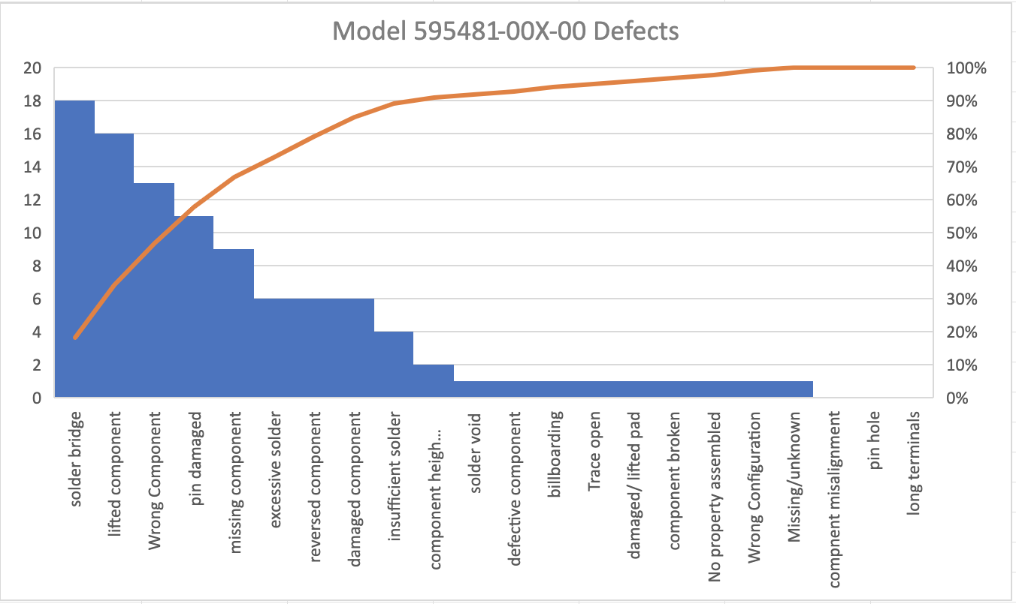

This next pareto chart shows the number of defects for model 595481-00X-00. The data in this chart shows that solder bridge contributes to the greatest number of defects at 90%. We then have lifted component next with 80% of defects. Lastly, the third and fourth part that produces the majority of defects are wrong component at about 65% and pin damaged at about 55%. For this model solder bridge had 18 defects, lifted component had 16 defects, pin damaged had 11 defects, and missing component had 9 defects.

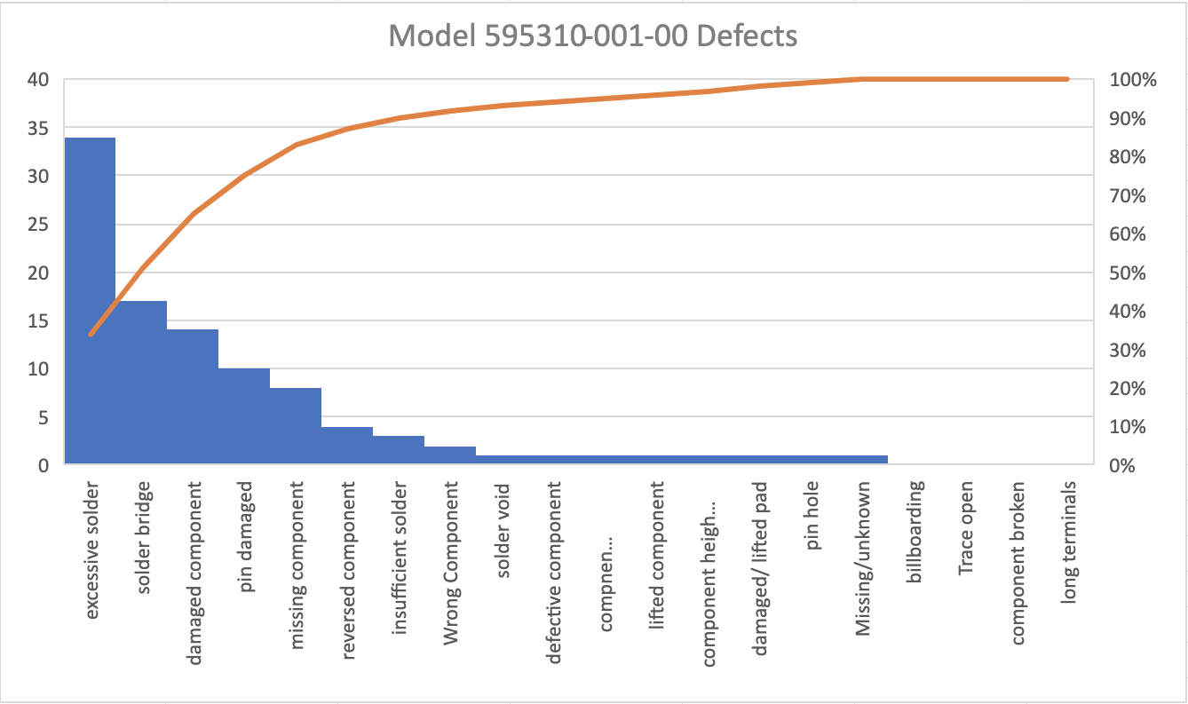

The last pareto chart shows the defects for the model 595310-001-00. Analyzing the chart, we can see that the most occurring defect for this model is excessive solder at about 87%. The next two most occurring defects for this model are solder bridge at around 44% and damaged component at about 38%. Excessive solder has 34 defects in this model. The solder bridge has 17 defects, and the damaged component has 14 defects.

**Root Cause Analysis**

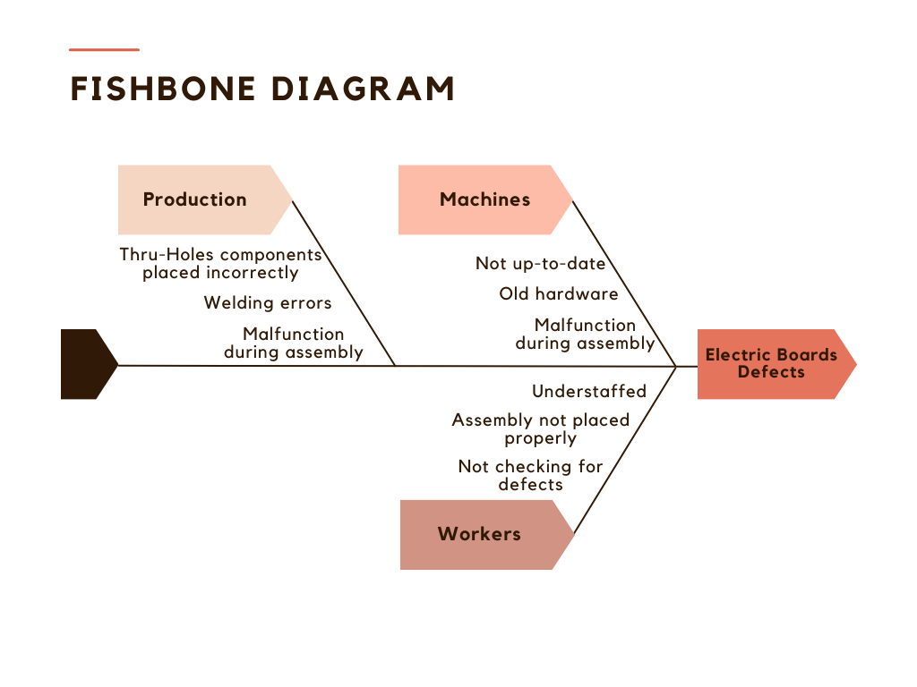

This fishbone diagram displays all of the possible causes of the electric board assembly defects. I have identified three different categories which are production, machines, and workers. Under production I have determined that some possible causes of the root cause could be that during production the Thru-Holes components are not placed correctly causing a defect. Also welding errors during that step of the production process can lead to defects with the assembly. Lastly, under this category any type of malfunction during the assembly could lead to defects with the electric boards. The next category I labeled was machines. Under this category a possible cause of the defects is having machines that are not up to date causing them to not perform at their best. The hardware on the machines could be old and rusty causing them to break. Like the first category the machines could be malfunctioning during the assembly causing defects. The final category is workers. The workers could be understaffed in the quality inspecting department therefore missing any defective electric boards. Some workers could not be up to date on their training causing them not to place the assembly properly. Lastly, some of the workers could just simply not be doing their job properly and purposely not checking for defects. All these areas that relate to the root cause could give the company insight into how to resolve the problem. The solution could be as simple as increasing training for workers or upgrading the machinery.

**References**

Southern New Hampshire University (n.d.) “DAT 475 Project Case Study” <https://learn.snhu.edu/content/enforced/1610838-DAT-475-12752.202451-1/course_documents/DAT%20475%20Project%20Case%20Study.pdf?ou=1610838>